Nathan Maynard and Calen Jones
Dr. Nicholson
CSCI 4805

Capstone Cooking Final Report
1. Introduction
This project set out to build a personal and public recipe management system that has flexibility and a responsive interface. The goal was to create a tool that allows users to store, edit, and organize their own recipes in a robust and customizable way, rather than the way that traditional recipe apps appear. The system was designed to support markdown formatting, searchable ingredients and tags, scalable portions, image uploads, and a storage directory system for the user while still being user-friendly and lightweight. The intention was not to just make recipe storage convenient, but to let the users have full control over their data without relying on a proprietary platform.
The intended use is for home cooks, students, or anyone who would rather use a customizable storage system rather than a generic advertisement-riddled third party platform. Because this app focuses on practicality and speed instead of social features, the scope remained focused on individual organization: Editing and viewing recipes cleanly, maintaining organized ingredient lists, and navigating personal collections. Markdown support was included as a part of this because it allows the users to structure their recipes naturally with headings, lists, and other formatting without needing a separate writing tool.
While the initial feature list was very broad, the final implementation for our presentation delivers a functional core application primarily focusing on recipe editing, markdown previewing, and image handling. Outside of the scaling functionality, we delivered a fully functional recipe card editor that allows for ingredients and amounts, servings, prep and cook times, and public or private storage options. The core workflow from creating a recipe to saving it to the database works reliably, however we were unable to implement some features in time such as tag management, recipe scaling, unit conversions, and directory routing.
The system’s architecture is built on a straightforward and efficient stack using SolidJS as it provided a reactive UI and efficient re-rendering for reactive components. We also tried starting with SolidStart as a baseline for setting up the project, however we had to make some changes later on to allow for functional deployment.

2. Technology
Our project relies on a small modern technology stack built around SolidJS for the front end and Supabase for storage and authentication. Each tool that we selected had an impact on our development approach and experience, especially since we had to make some last minute changes to fix deployment limitations. These technologies we ultimately kept were chosen because it allowed for browser responsiveness and a good boilerplate to build from, which made it easier to move quickly using a development server.
We picked SolidJS because of its lightweight reactivity model compared to React and it does not require a virtual DOM. Our recipe editor is constantly updating fields, render markdown previews, handle thumbnail images, and using Solid components to build the application kept the UI fast. There was a moderate learning curve; is does have a similar conceptual design to React, but the way it renders and runs computations is different. Because of this, it made the development simpler and reduced the state management code needed.
SolidStart was originally used to build up the application with routing and file-based project structure, and optional server side rendering. However as we worked through the project, some of the rapid version changes in SolidStart left a lot of gaps and differences in the documentation, making it hard to stabilize. Originally we used a newer version of SolidStart that ran on Vinxi and SSR, but as we tried to deploy it this caused some major complications. Once migrated, we were unable to use the application past signing in with Google. Since our project really does not need server-side rendering, we switched to version 0.3.11 which has a static adapter. This entirely removed Vinxi from the project, as well as the unnecessary API calls to the server side, which made deployment possible. To do this we just had to build the typescript app which exported it as a static. If we had started with the static approach from the beginning it would have made the development process much easier.
Vite is used as our built tool and dev server. This worked reliably for the project and really did not have much of a learning curve to use it. It also had a big advantage with the instant reload speed making UI development much quicker. It also interacts well with SolidJS through a plugin, requiring no extra setup.
Supabase handles the authentication, database storage, and image uploads for this project. It was very straightforward for operations like storing recipe rows in the database, uploading photos to a storage bucket, and the dashboard made it very simple to manage the tables and settings. One of the main difficulties came from Row Level Security, as it is strict by default so we had to temporarily relax the policies to focus on core implementations. Supabase made development much easier overall as it lessened the need for tedious back-end code, and even after switching the app to static last minute for hosting it required minimal work to reconnect.
We used TypeScript across our project as the development language. Since our data structures coming from the recipe editor are predictable, TypeScript helped us prevent runtime errors through enforced type safety and allowing us to iterate through features more quickly. It was also partially picked because Nathan had built some previous mini projects and felt most comfortable with Typescript for web applications.
For the markdown editor portion of our project, we used a lightweight markdown rendering library called Markdown-It to render the string of recipe instructions into HTML rendering. This helped the application feel closer to a real document editor without having to build large formatting tools from scratch, and it was easy to implement without any major issues. We also implemented “tag highlights”, indicating the opening and closing tags for markdown elements like bold and italicizing, similar to how VSCode highlights brackets and parenthesis for visibility. This was because handling the tags within small blocks of text rather than single lines had caused some complications with matching the tags to each other for proper rendering, and we kept it as a production feature since it would help users who are unfamiliar with Markdown understand what is going on as well.
Toward the end of our development, we had to make several quick changes to support the deployment. We were originally going to be hosting the application with Vercel, but due to service outages we had to deploy it on Netlify instead. Because of the way Netlify handles hosting we had to make our code static and remove some of the reactivity. While most of our features still worked out fine when hosted on this platform, after presenting the software we realized that Netlify would not be good for long term hosting. This is because directly after our presentation saying that after 2 days of testing and demonstrating, we had received an email saying that half of our credits for the month already. After doing further research we found that non-responsive websites are free to host, however form submissions are crucial to our application and they cost one credit each meaning that we would be incurring charges very quickly after regular use of our website, even just with one or two users.

3. Design
The UI design of the web application is primarily component based. The dashboard is the main component of the app and is divided between three sub-components, as seen below:
- Taskbar- top bar
- Recipe Browser - right-side panel
- Main Area- middle section
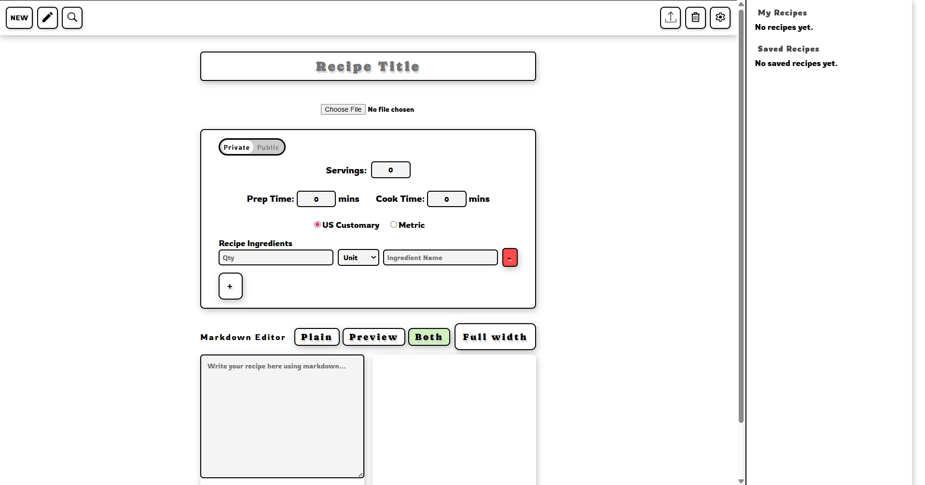l

Main Area

The main area of the dashboard is the most interactive portion of the dashboard, defaulting the screen you see above (New), but updates to different screens depending on the buttons selected from the Taskbar or the Recipe Browser.

Taskbar

The taskbar (implemented in taskbar.tsx) is comprised of six buttons:
- New
- Edit
- Search
- Export
- Delete
- Settings

These buttons are responsible for changing some of the screens that display in the Main Area. These buttons are linked to components: recipeEditor.tsx (for New and Edit), SearchRecipe.tsx, ExportPDF.tsx, DeleteRecipe.tsx, and Settings.tsx.

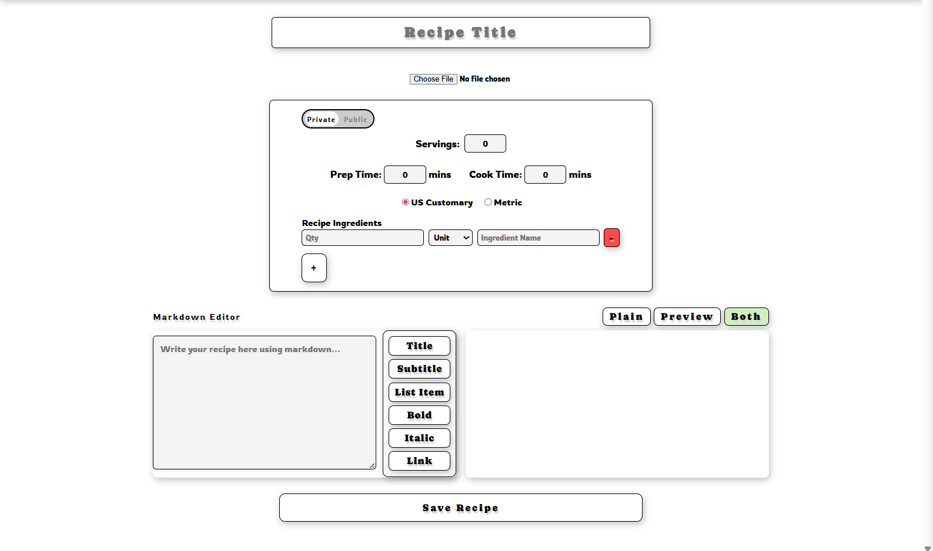

When the “New” button is clicked in the taskbar, the above screen is displayed. This screen is responsible for submitting a new recipe, which will upload in the recipes table in Supabase. The following keys are updated in the recipe table upon submission:
- Recipe title Field -> “recipe_title”
- Choose File (image upload) -> “image_url”
- Servings -> “servings”
- Prep Time -> “prep_time”
- Cook Time -> “cook_time”
- Private/Public Toggle -> “is_public”
- Ingredient Form (dynamic) -> “ingredients”
- Markdown Editor (content within) -> “contents”

The Image Upload button, if a user chooses a photo from their personal computer, will upload the photo to Supabase Auth; this will generate a URL path for retrieval, and this URL is stored as the value for recipe’s “image_url” key,

The US Customary and Metric Toggle buttons update the units in the units dropdown to switch from the sooner to latter.

The Markdown Editor is responsible for allowing the user to customize the steps, notes, and other text that they include inside of the text area in that section, enabling headings, subheadings, lists, bold and italic formatting, and embed hyperlinks. The markdown formatted text is saved in “contents”, and the white box to the right of the textarea when “Both” or “Preview” is selected will render this raw text.

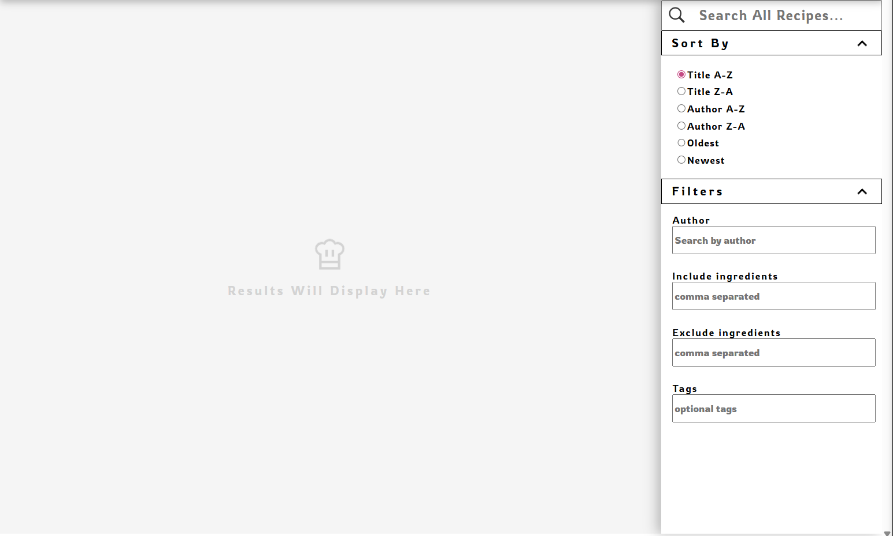

When the magnifying glass in the taskbar is selected, the screen in the Main Area of the dashboard updates the SearchRecipe component. The purpose of the search page is to allow users to browse and search personal recipes based on the title or advanced search criteria. The SearchRecipe page is divided between a viewing area that displays search results and a side panel that displays a search bar and sort by/filter options. The available sorting options are: Title (ascending/descending), Author (ascending/descending), and Oldest/Newest (creation date ascending/descending. The available filter options are: Author, Include Ingredients (returns results that include the ingredient in their ingredient list, separated by commas), Exclude Ingredients (returns results that do not include the ingredient, separated by commas), and tags (searches instances of word in recipe, tags feature in recipe not implemented.

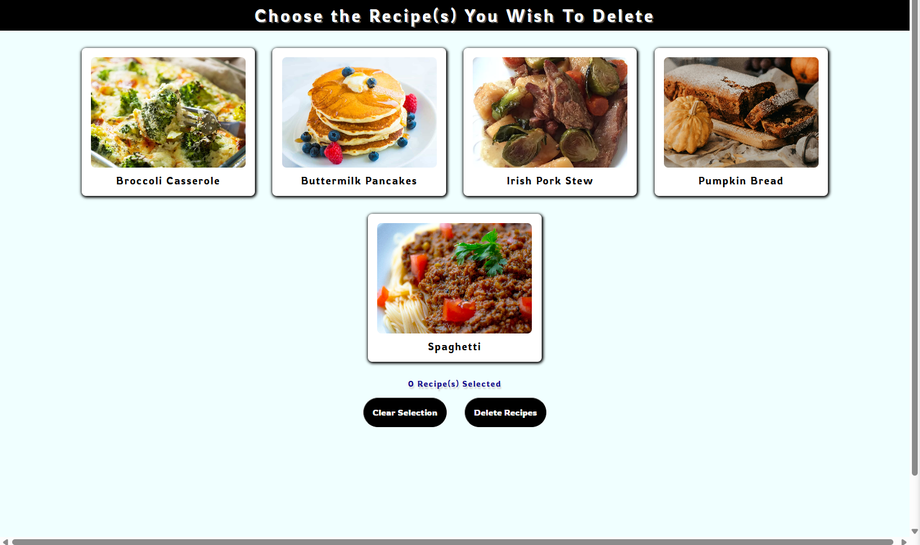

When the trashcan icon is clicked, the screen in the Main Area changes to the Delete Recipe screen. The purpose of this page is to allow the user the ability to delete recipes they have personally added to the database. The page has a multi-select functionality that allows the user to select one more recipes, which will auto-update the value to the left of “Recipes Selected” to the number of recipes selected. If the user selects the “Clear Selection” button on the page, any recipes selected will be deselected. If the “Delete Recipes” button is selected, the app should ask the user for confirmation that they wish to delete and permanently delete the recipes the user selected from Supabase (see Known Issues).

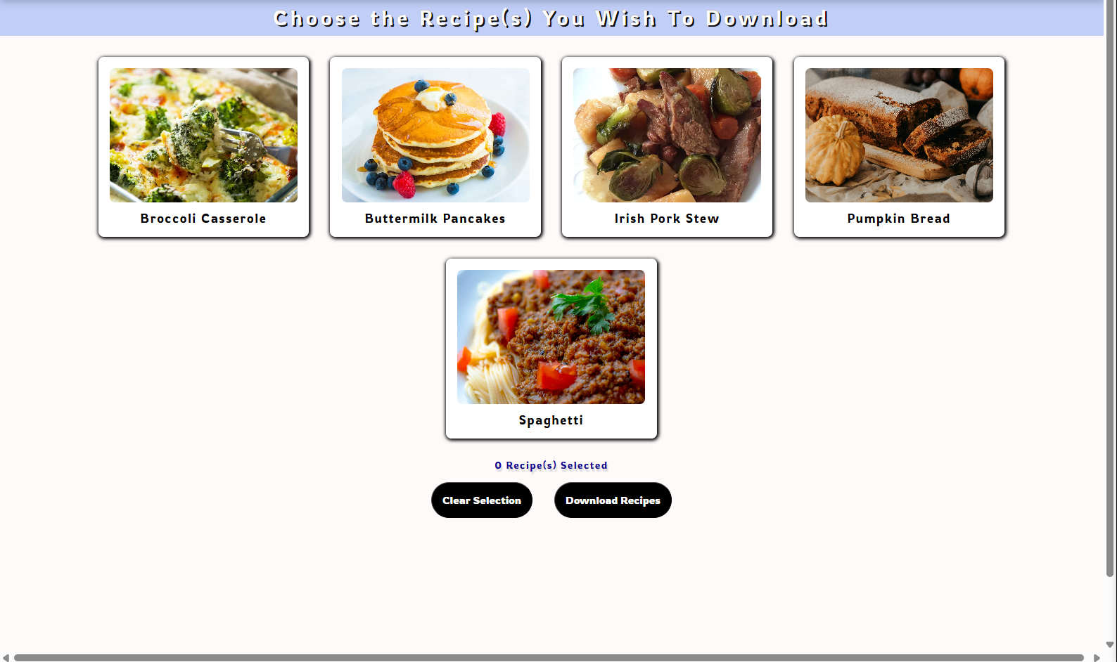

When the Export button is clicked from the taskbar, the Main Area of the dashboard updates to the above screen. The Export To PDF page is responsible for allowing the user to select one or multiple recipes to download and/or save recipes to their personal computer. The multi-select functionality allows the user to choose one or multiple, and the numeric value next to “Recipe(s) Selected” will update accordingly. If the “Clear Selection” button is clicked, any selected recipes will deselect. If the “Download Recipes” button is clicked, the app should pop-up a window generating a PDF of the recipe cards belonging to the recipe tiles that the user selected and allow the user to save it to their local computer (see Known Issues).

Recipe Browser

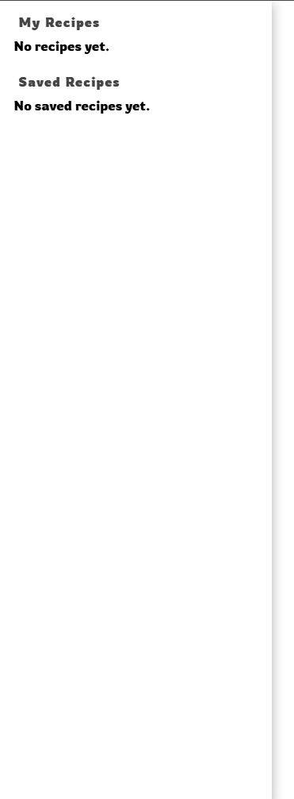 | 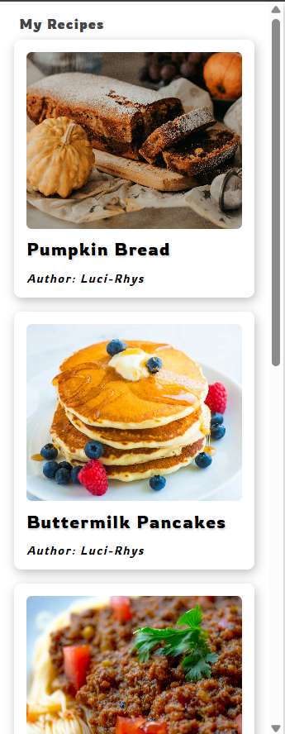

The purpose of the Recipe Browser is to display recipe tiles of the recipes that user has personally authored or saved to their own collection from other authors (default -> left, saved recipes -> right); the recipe tile displays the photo of the recipe (user-uploaded or default), the recipe title, and the recipe author. When a recipe is selected from the Recipe Browser panel, the recipe tile is highlighted with a border of red, and the recipe is displayed in the Main Area of the dashboard in a view mode, as illustrated below.

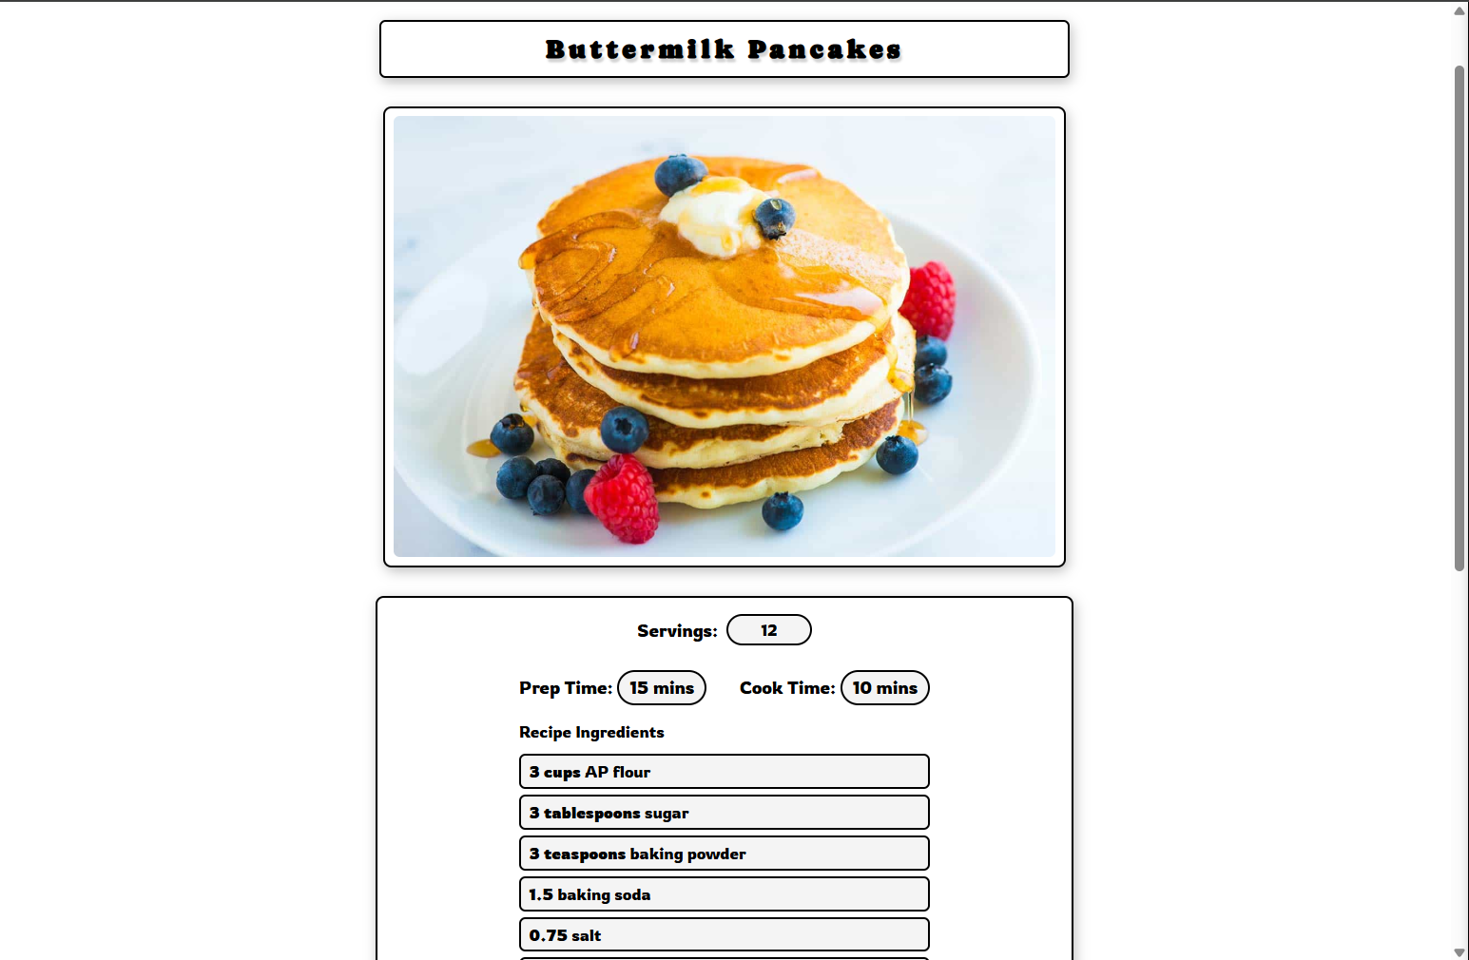 | 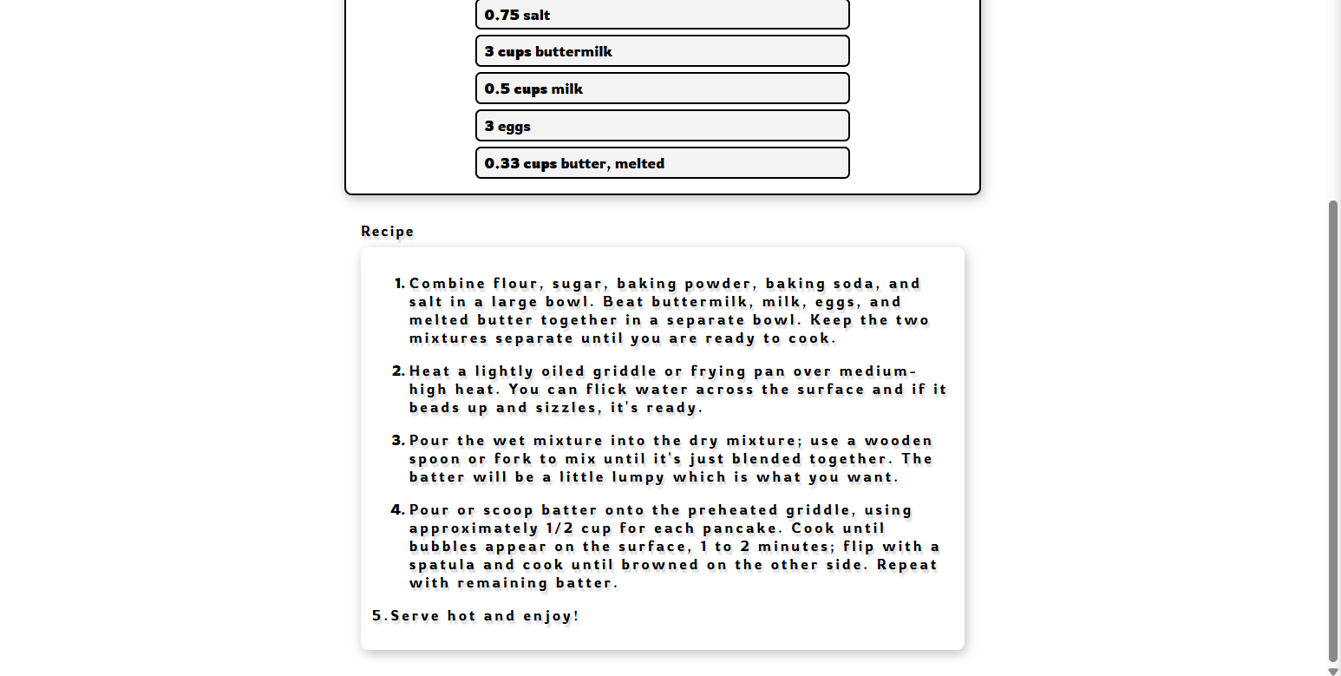

In viewer mode (shown above is one screen, condensed for space), the recipe card features the recipe title, recipe photo, servings, prep time, cook time, ingredients, and recipe contents (steps and notes); the card is uneditable on this screen, regardless of ownership, and its purpose to display recipe cards. If the user has selected a recipe they personally authored, is currently on the above screen, and selects the pencil icon on from the taskbar, the Main Area updates to edit more, displaying the screen shown below (again, one screen split into two pictures for space).

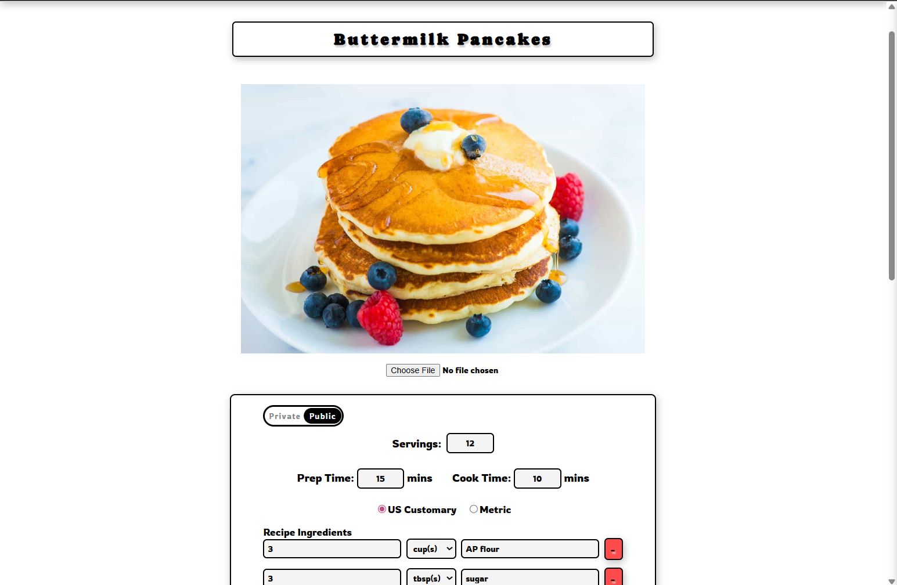 | 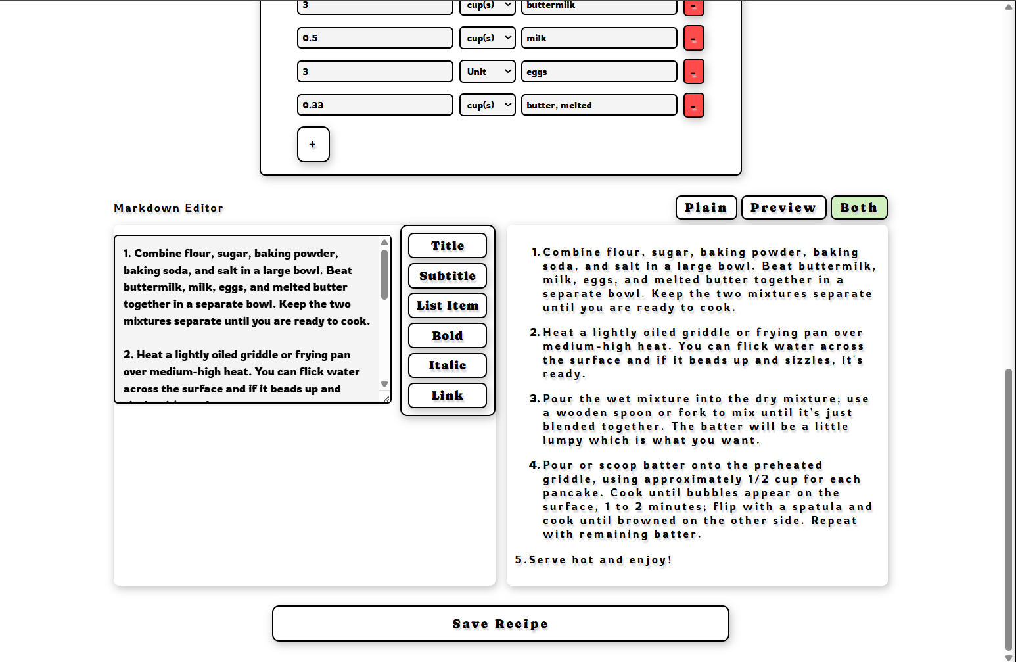

In edit mode, the user is able to make edits to their recipe, such as the photo, title, publicity, ingredients, content, etc. If changes are made to the form, these edits update the respective keys in the Supabase that was outlined about in the New Form section upon clicking “Save Recipe” that submits the form.

Database Design
The design of the database changed from a normalized database to a more condensed denormalized database. Below is the previous ERD to display how tables were organized.

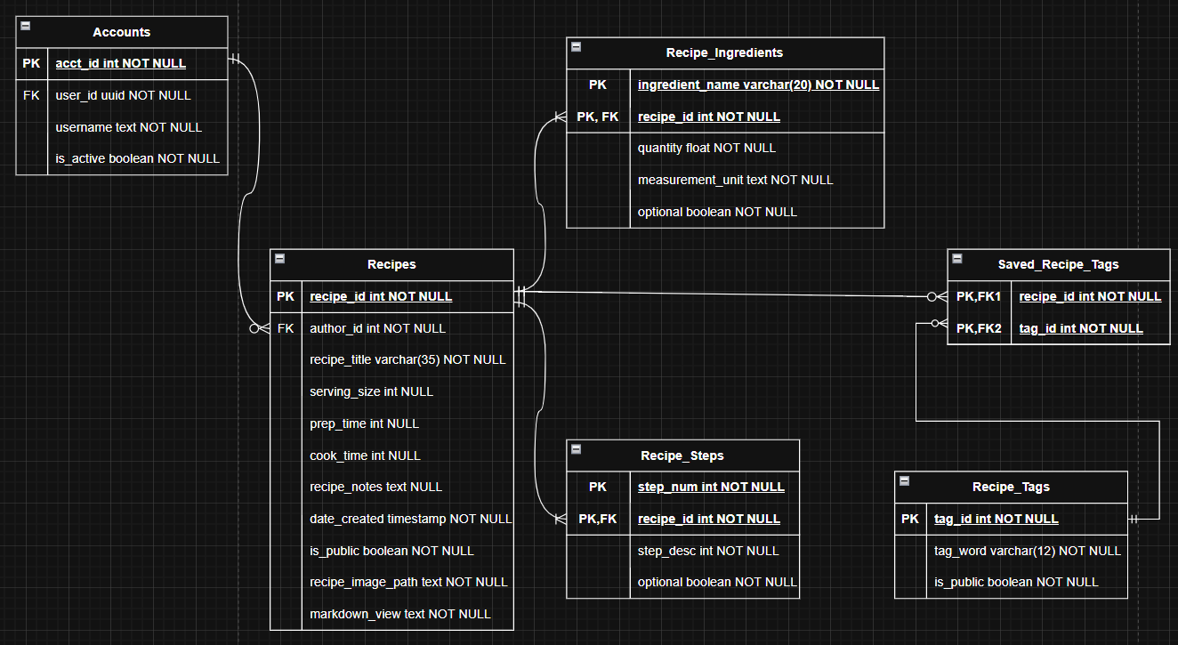

The tables were separated into Accounts, Recipes, Recipe_Ingredients, Recipe_Steps, Recipe_Tags, and Saved_Recipe_Tags. This was later condensed to just a users and recipes table, as shown below.

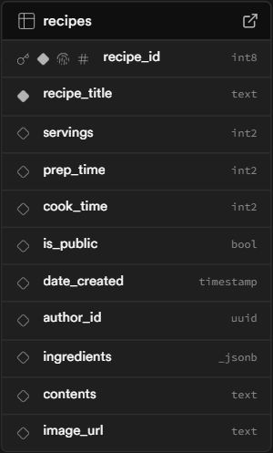 | 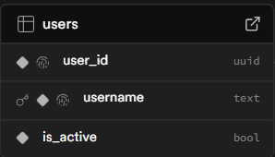

The Accounts table was renamed to users, the Recipe_Tags and Saved_Recipe tags were removed, and the Recipe_Ingredients and Recipe_Steps were integrated into the recipes table as “ingredients” and “contents” keys. With the exception of more complex queries for retrieval and settings constraints on the keys (specifically ingredients and contents), this denormalization has little effect on the web application

Currently, recipes table holds the keys: recipe_title (recipe title), servings (serving size), prep_time (time to prepare recipe), cook_time (time needed to cook recipe), is_public (boolean for publicity of the recipe), date_created (auto-adds date/time at creation), author_id (uuid of user who wrote the recipe), ingredients(json formatted: “unit”, “quantity”, “ingredientName”), contents (text of steps, notes, etc.), and image_url (URL of the photo saved in Supabase Storage).

Required Data Files

The assets stored with the project are found in the assets directory in the source folder. The icons necessary for the taskbar buttons are found in the sub-directory “dashboard”. The names lists for randomly generating the username is found in the sub-directory “names”. The remaining photo assets we use are found directly in the assets folder, which includes the chef hat present on the search page, the default recipe image if a user does not upload an included recipe, and the Google button image and food picture found on the main login page.

The system uses a small set of data structures to represent recipes, ingredients, user metadata, and state saving. Instead of saving the ingredients globally for autocompletion, the app just stores them locally as text in the recipes. This keeps the schema simple but limits functionality of cross-recipe browsing such as a global ingredient search or unit normalization. Most of these are within the recipe editor and viewer components, which serve as the primary interfaces for the application.
The recipe model is structured to contain all of the data associated with one recipe. In the editor the initial empty structure is defined with fields for the ID, author, title, prep and cook time, servings, ingredients, markdown content, a public flag, and an image path. When fully loaded, a recipe will contain the recipe ID, author ID, and recipe title, and text values stored for the ingredient list and markdown content. This state is normalized through the CloneRecipeState function which sets unsaved values to a default for safety. Within the viewer, the model is represented as a RecipeData object, mirroring these fields and computed to render the HTML output. The viewer has a markdown renderer that converts the plaintext string in the contents into rendered markdown text for display.
The ingredient model is represented as 3 fields: the quantity, unit, and name of the ingredient. This is separated as 3 different inputs for the editor, or one cohesive string under the viewer. These are managed by addNewIngredient, updateIngredient, and deleteIngredient. They are stored exactly as the user enters them, as no globality of these variables has been implemented yet.
The search and sort functionality is working mostly, but still needs some fixes. as you type into the search bar it does pull a list of recipes based on the text you entered, but it is not always clear where this text is coming from in a given recipe: it could be an ingredient, title, or any text entered into the markdown section of the recipe. The sorting filters also do not always sort or render as intended as well.

4. Deployment / Build Instructions
The first step to deploying the web application is to clone the project from GitHub; the easiest way to achieve this is to go to Nathan’s repo (https://github.com/ncmaynard03/recipe-app) , click the green Code button, and copy the url from the HTTPS page. Afterward, the user needs to open Visual Studio Code, and run the command: git clone https://github.com/ncmaynard03/recipe-app in the terminal. Install the latest version of Node.js. The user must create a file “.env.local” and add the Supabase Project URL, Supabase Publishable key, and the Supabase Auth Google client secret found on the Google Cloud Platform. Run npm install to install project dependencies from project’s package.json file.

To set up Supabase, go to supabase.com and set up an account with Supabase. Once the user is at the dashboard in Supabase, to set up a new project, the button “New Project” must be clicked. The user creates an organization and creates a project name and selects “Create New Project”. Once in the project, the user can either use the SQL Editor or Table Editor to create new tables; the latter is the easiest.

After selecting “Table Editor”, the user will click “New Table” to create a new table. The user needs to create a users and recipe table with the keys outlined earlier in the report; the user will do this by updating the key names from earlier in the columns sections of this new screen, including the types displayed above. A foreign key relationship should be set between the author id in the recipes table and the user id in the users table. A storage bucket must also be set up for the storage of the recipe photos; this can be achieved by selecting Storage from the left sidebar options and choosing “New Bucket” on the next screen. The user must create a bucket name and set the publicity of the bucket. Row Level securities restricting all actions to authenticated users must be made. Further policies on the recipes table must be made to ensure that users can only see, update, or delete recipes from the recipes table if the author id of the recipe matches the same user’s user_id. The exception to this is for public recipes, in which the RLS will need to be set to allow all authenticated users to view recipes whose “is_public” key is set to TRUE.

5. Known Issues

Several known issues exist related to missing or unimplemented features, bugs, and RLS policies.

Missing Features

The scaling feature, which allows users to scale the recipe by different factors, was missing from the recipe viewer screen. This screen is visible in the Main Area component when a recipe is selected from the Recipe Browser side panel or when a recipe is searched for and selected from the results. Implementation of this feature would be easy to do once the element is added to the page, only further requiring a function that multiplies the current value of the form, retrieved by a signal, and updates these values in the recipe card.

Unimplemented features

The Export to PDF function was left unimplemented due to concerns over performance, complexity, and time constraints. Since recipes can be of variable length, we need a solution that will allow us to control styling and sizing to ensure that recipes of any length are reasonably rendered, readable, and consistent. Browsers have a built-in print option that allows users to print a page and then download it as a PDF; however, there is limited control over the layout, so this option was not pursued. Consideration was given to the library pdf-lib to customize the sizing and layout of recipes and generate PDFs that the user would be able to add to their personal computer; however, the initial installation of the library slowed the response time of the site. The feature was one of the last to implement, so it was a better decision to uninstall the library than to spend time troubleshooting the issue and risk the performance. With more time, alternative libraries, such as PDFKit or jsPDF, can be explored, or troubleshooting pdf-lib is an option.

The Delete Recipe function was left unimplemented due to the last-minute deployment changes and time; the DeleteRecipe.tsx file, before the deployment change, had the delete recipe functionality saved to a separate branch. The use of Vite and Netlify changed how data is retrieved, so the functionality saved on the remote branch was no longer compatible, and we ran out of time refactoring it to work with this new implementation. The team approach would be to take more time finishing the refactoring and integrate it with the new code.

The Save Recipe function was also unimplemented. When a user is searching for recipes on the Search Recipe page, after clicking on a public recipe, there is a button in the top right corner of the recipe viewer that should allow the user to save this recipe to their Recipe Browser side panel for easy retrieval in the future. This functionality was partially implemented but never finished, so clicking the button does nothing. One approach would be to implement a public_recipes table and a saved_public_recipes tables; these tables, respectively, could allow us to save the recipe cards of public recipes, and the user ID’s of the users that that saved these recipes for easy retrieval and placement in the Recipe Browser side panel.
The tags feature was left unimplemented. The original design gave the user the ability save specific tags as “private” or “public” as an easy link to similar public and personal recipes. The database was denormalized, for the most part, and the text content, with the exception of the title and the ingredients, is contained in the “contents” key in the recipes table in Supabase. The search page has a filter option for “Tags”, which searches the content of the recipe, so a separate tags feature may not be recipe. Further, tags are generally indicated by a “#” sign, and as the text area for the notes and instructions also serves as the markdown editor. If we were to implement this feature, we would need to designate another tag indictor, as “3” in Markdown is reserved for h1/title elements.

Unit conversions were unimplemented on the app and missing from the recipe viewer itself. The radio buttons “US Customary” and “Metric”, visible on the “New Recipe” screen, toggle and update the available units to choose from in the Unit(s) dropdown; these update and save to the database as intended. However, these toggles should also be featured on the recipe viewer screen when the user selects a recipe from the Recipe Browser side panel or searches for a recipe and selects one from the search results, but they are not there. The functionality to convert units is much more complex than we previously thought, and leaving the toggle buttons in the recipe viewer form caused the pre-saved units to clear the form instead of changing values. Resolving this would involve more time to implement and/or research JS libraries that have built-in functions to perform the conversions.

Bugs

The “Newest” and “Oldest” Sort By options do not sort the search results on the SearchRecipe page; toggling between the two has no effect in general. In the recipes table in Supabase, the key “date_created” auto-generates and inputs the date and time a new recipe is created upon submission. Looking at the code we’ve written, it seems the incorrect key may have been called for the creation time of the recipe. If we update with the correct key name, then these search sort toggles should work. In case it does not, since the sort options work with no issue, the team approach would be to investigate how the data is being retrieved from Supabase.

Security

Some of the Row Level Security (RLS) policies were left intentionally lax for the sake of the presentation and demonstation, e.g. the recipes_with_usernames view table. For better security in a live application, tighter RLS policies would need to be enforced and tested to ensure that all users are authenticated, and users can only access and update their own content, with the exception of public and/or saved recipes which will allow access.

Limitations

The change from Vercel to Netlify required the change from a dynamic to a static adapter to deploy the web application with no issues. The tradeoff of this change is that the static adapter does not support user directories, so user data must be fetched each time instead of stored.

